OS LAB ASSIGNMENT 3

SINADIN SHIBIN , R4 , 64
14-05-2021

Q1 : Write a shell script program to display the name of the current working

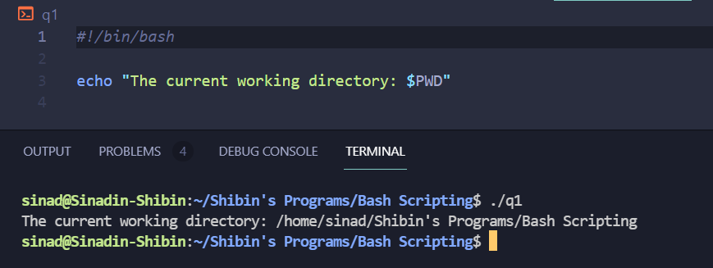
Q2 : Write a shell script program to perform arithmetic operations on two numbers.

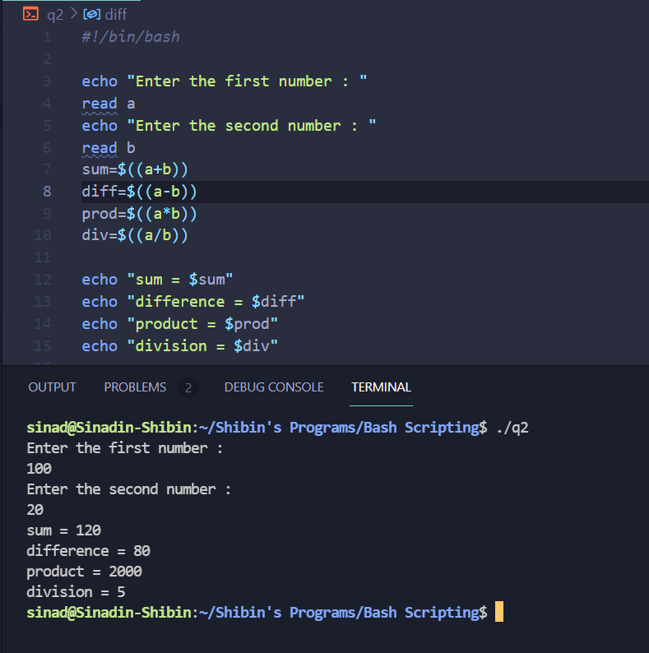

Q3:Write a shell script program to pass arguments to the program and display the
count of arguments and content
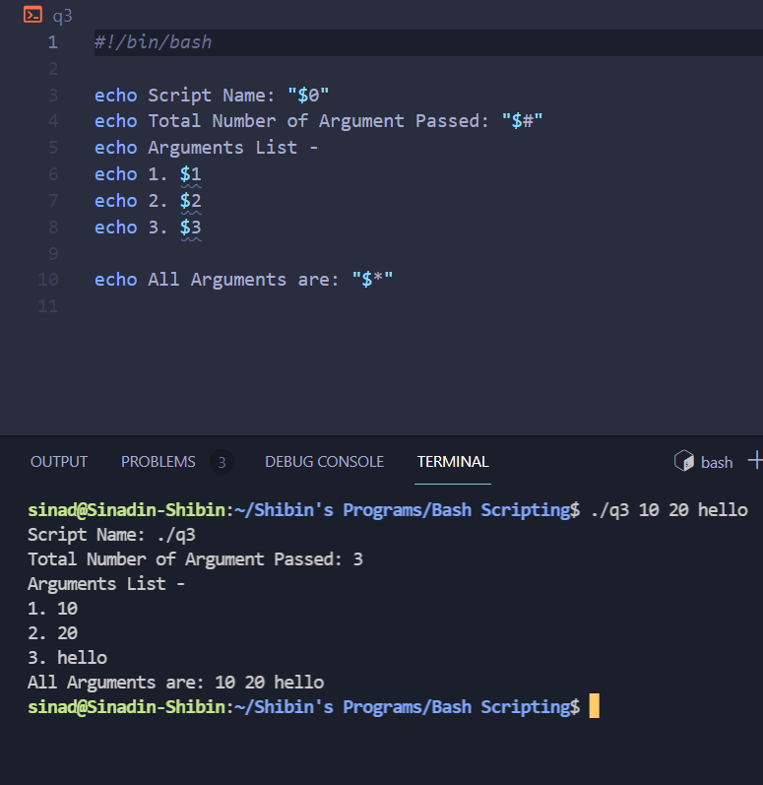
Q4 : Write a shell script program to test whether 3 arguments are being passed to it
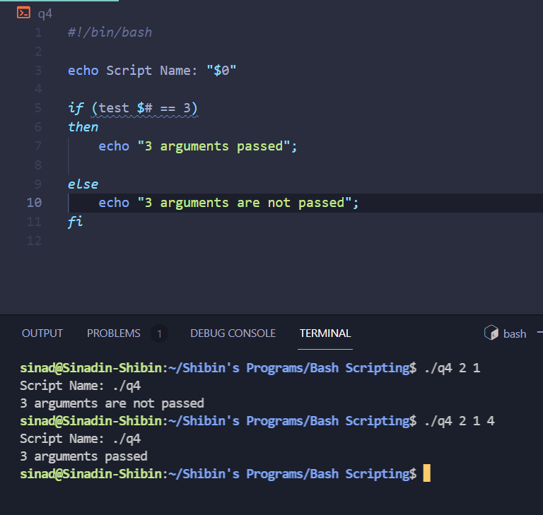

Q5 : Write a shell script program to check whether two strings sent as command
line arguments are same or not using test command.
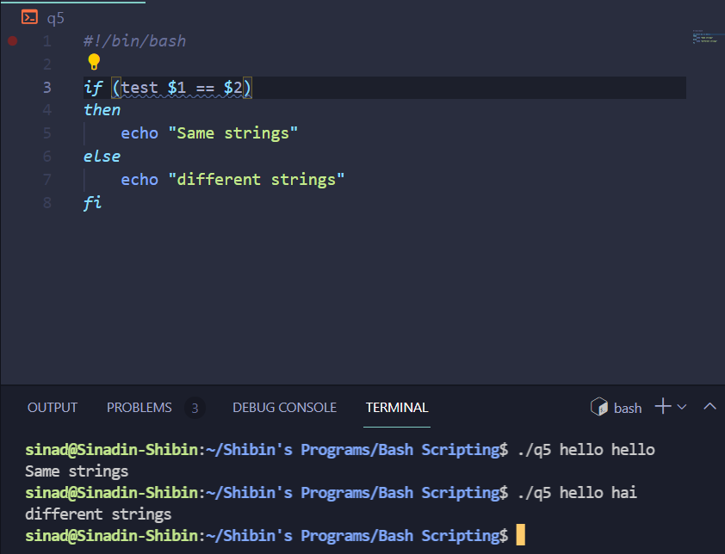
Q6: Let argument be a filename. Write a shell script program to check whether the file exists or not
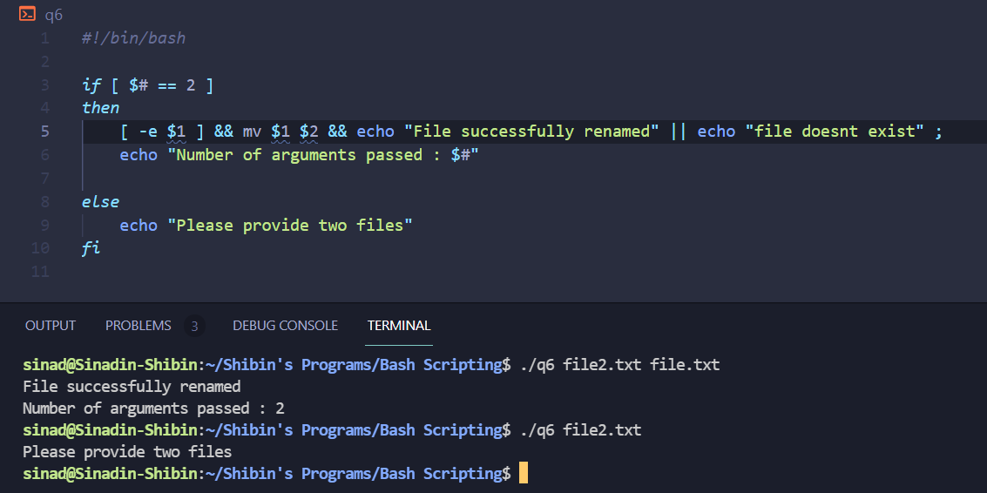

Q7: Write a shell script program to test whether a string is present in a file or not.

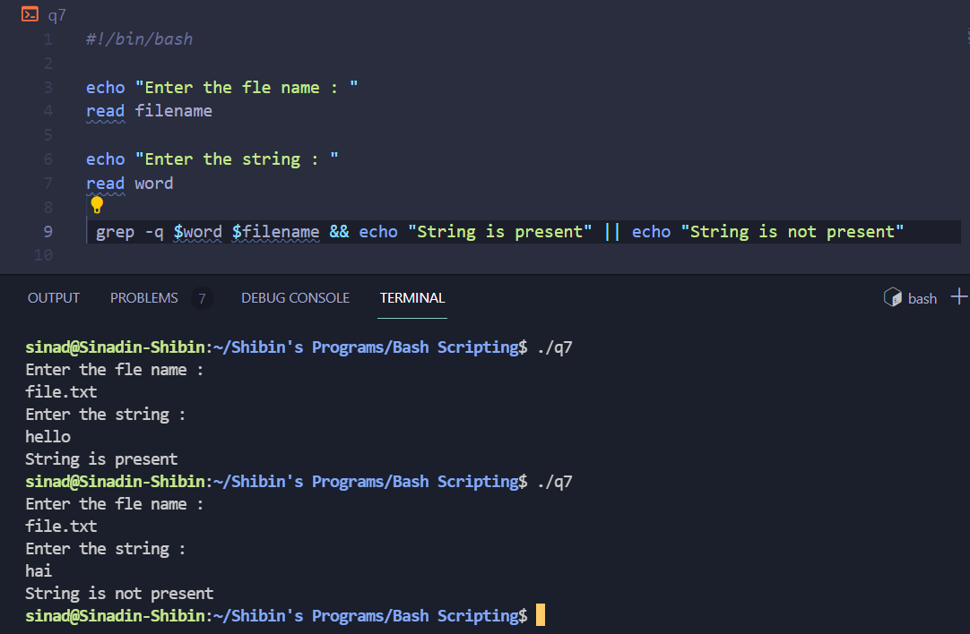

Q8 : Write a shell script program to copy content of file1 to file 2. If file2 exists
then append the content of file1 to its original content
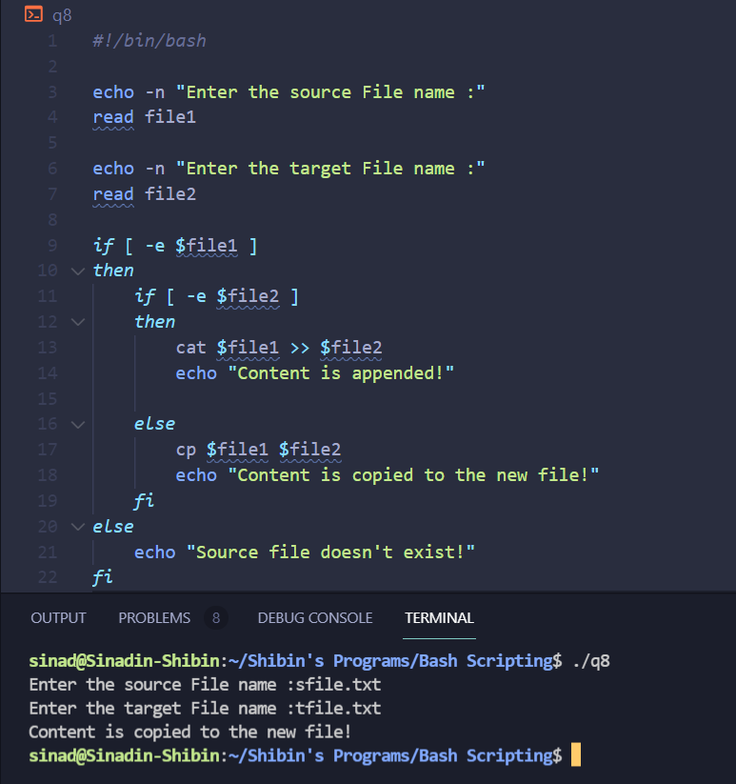

Q10: Write a shell script program to show number of files in the current directory
beginning with a specified character

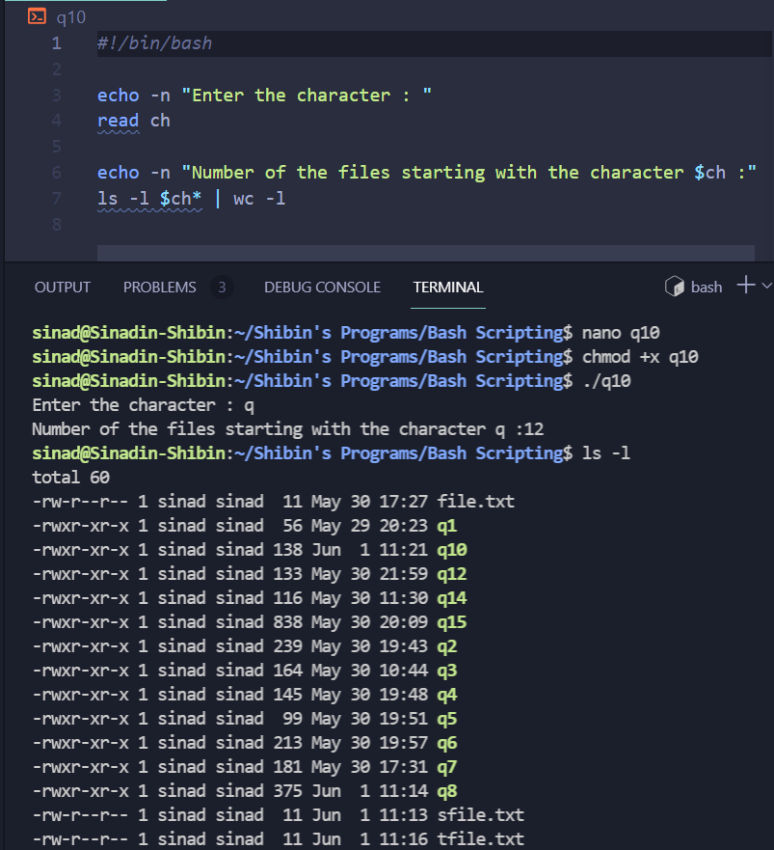

Q14 : Write a shell script program to display sum of first n numbers

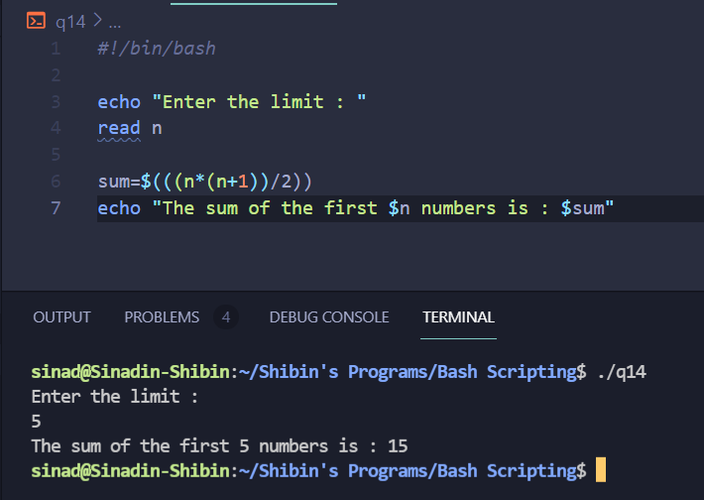

Q12: Write a shell script program that accept the name of the user and prints the
entire name in reverse and also print the length of the entire name

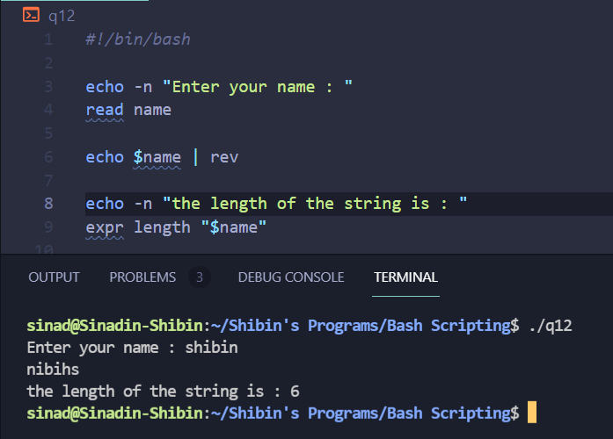

Q13 : Consider a file school.dat with the following fields: roll no, name and marks.
Write a shell script program to sort the file in descending order of marks

